Aim: To obtain the classification of various classes using k-Nearest Neighbor approach
IDE: Google Colab

Theory:
This algorithm is used to solve the classification model problems. K-nearest neighbor or K-NN algorithm basically creates an imaginary boundary to classify the data. When new data points come in, the algorithm will try to predict that to the nearest of the boundary line. Therefore, larger k value means smother curves of separation resulting in less complex models. Whereas, smaller k value tends to over fit the data and resulting in complex models. It’s very important to have the right k-value when analyzing the dataset to avoid over fitting and under fitting of the dataset.

The model representation for KNN is the entire training dataset. It is as simple as that. KNN has no model other than storing the entire dataset, so there is no learning required. Efficient implementations can store the data using complex data structures like k-d trees to make look-up and matching of new patterns during prediction efficient. Because the entire training dataset is stored, you may want to think carefully about the consistency of your training data. It might be a good idea to curate it, update it often as new data becomes available and remove erroneous and outlier data.

K-NN algorithm assumes the similarity between the new case/data and available cases and put the new case into the category that is most similar to the available categories. K-NN algorithm stores all the available data and classifies a new data point based on the similarity. This means when new data appears then it can be easily classified into a well suite category by using K- NN algorithm. K-NN algorithm can be used for Regression as well as for Classification but mostly it is used for the Classification problems.

K-NN is a non-parametric algorithm, which means it does not make any assumption on underlying data. It is also called a lazy learner algorithm because it does not learn from the training set immediately instead it stores the dataset and at the time of classification, it performs an action on the dataset. KNN algorithm at the training phase just stores the dataset and when it gets new data, then it classifies that data into a category that is much similar to the new data.

Example: Suppose, we have an image of a creature that looks similar to cat and dog, but we want to know either it is a cat or dog. So for this identification, we can use the KNN algorithm, as it works on a similarity measure. Our KNN model will find the similar features of the new data set to the cats and dogs images and based on the most similar features it will put it in either cat or dog category.

Methodology:
- Load the basic libraries and packages
- Load the dataset
- Analyse the dataset
- Pre-process the data

- Visualize the Data
- Separate the feature and prediction value columns
- Select the number K of the neighbors
- Calculate the Euclidean distance of K number of neighbors
- Take the K nearest neighbors as per the calculated Euclidean distance.
- Among these k neighbors, count the number of the data points in each category.
- Assign the new data points to that category for which the number of the neighbor is maximum.
- Our model is ready.

Pre Lab Exercise:

- What is K in KNN-approach?

K represents the number of nearest neighbors considered to classify a data point (or predict value).
The algorithm finds the K closest data points and assigns the class based on majority voting (for classification) or
average (for regression).

- Which are the types of distance metrices?

Common distance measures used in KNN:

- Euclidean Distance
- Manhattan Distance
- Minkowski Distance
- Hamming Distance
- Cosine Distance
- Chebyshev Distance

- What can be the criteria of selection of the value of K?

• Choose K using validation or cross-validation
• Small K → sensitive to noise (overfitting)
• Large K → smoother decision boundary (underfitting)
• Usually choose odd K to avoid ties (for binary classification)
• A common rule: $K≈\sqrt{N}$where N = number of training samples

- What are the advantages of KNN algorithm?

• Simple and easy to understand
• No training phase (lazy learning)
• Works well for small datasets
• Can handle multi-class problems
• Non-parametric (no assumption about data distribution)
• Can be used for both classification and regression

Program (Code):

import time
import numpy as np
import pandas as pd
import matplotlib.pyplot as plt
import seaborn as sns

from sklearn.datasets import load_digits
from sklearn.model_selection import train_test_split, GridSearchCV
from sklearn.preprocessing import StandardScaler
from sklearn.pipeline import Pipeline

from sklearn.neighbors import KNeighborsClassifier
from sklearn.ensemble import RandomForestClassifier
from sklearn.neural_network import MLPClassifier

from sklearn.metrics import (
accuracy_score,
precision_score,
recall_score,
f1_score,
confusion_matrix
)

digits = load_digits()
X = digits.data
y = digits.target
images = digits.images

plt.figure(figsize=(8, 4))
for i in range(10):
plt.subplot(2, 5, i + 1)
plt.imshow(images[i], cmap="gray")
plt.title(f"{y[i]}")
plt.axis("off")
plt.suptitle("Sample Digits")
plt.tight_layout()
plt.show()

X_train, X_test, y_train, y_test = train_test_split(
X, y, test_size=0.2, random_state=42)

knn_pipeline = Pipeline([
("scaler", StandardScaler()),
("knn", KNeighborsClassifier())
])

knn_param_grid = {
"knn__n_neighbors": [3, 5, 7, 9, 13, 15, 20]}

rf_pipeline = Pipeline([
("rf", RandomForestClassifier(random_state=42))
])

rf_param_grid = {
"rf__n_estimators": [25, 50, 100, 200, 500],
"rf__max_depth": [None, 10, 20]}

mlp_pipeline = Pipeline([
("scaler", StandardScaler()),
("mlp", MLPClassifier(
max_iter=1000,
random_state=42,
early_stopping=True
))
])

mlp_param_grid = {
"mlp__hidden_layer_sizes": [(64,), (128,), (64, 64)],
"mlp__activation": ["relu", "tanh"],
#"mlp__alpha": [0.0001, 0.001],
"mlp__learning_rate_init": [0.001, 0.01, 1.0, 5.0, 10.0]
}

#Training the model
def train_with_timing(pipeline, param_grid):
start = time.time()
grid = GridSearchCV(
pipeline,
param_grid,
cv=5,
scoring="f1_weighted",
n_jobs=-1
)
grid.fit(X_train, y_train)
train_time = time.time() - start
return grid, train_time

knn_grid, knn_train_time = train_with_timing(knn_pipeline, knn_param_grid)
rf_grid, rf_train_time = train_with_timing(rf_pipeline, rf_param_grid)
mlp_grid, mlp_train_time = train_with_timing(mlp_pipeline, mlp_param_grid)

#Inferencing the model
def inference_time(model):
start = time.time()
model.predict(X_test)
return time.time() - start

knn_test_time = inference_time(knn_grid.best_estimator_)
rf_test_time = inference_time(rf_grid.best_estimator_)
mlp_test_time = inference_time(mlp_grid.best_estimator_)

#Evaluation
def evaluate_model(model):
y_pred = model.predict(X_test)
return {
"Accuracy": accuracy_score(y_test, y_pred),
"Precision": precision_score(y_test, y_pred, average="weighted"),
"Recall": recall_score(y_test, y_pred, average="weighted"),
"F1-score": f1_score(y_test, y_pred, average="weighted")
}

knn_metrics = evaluate_model(knn_grid.best_estimator_)
rf_metrics = evaluate_model(rf_grid.best_estimator_)
mlp_metrics = evaluate_model(mlp_grid.best_estimator_)

#Result with comparison
results_df = pd.DataFrame(
[knn_metrics, rf_metrics, mlp_metrics],
index=["KNN", "Random Forest", "MLP"]
)

results_df["Training Time (s)"] = [
knn_train_time, rf_train_time, mlp_train_time
]

results_df["Inference Time (s)"] = [
knn_test_time, rf_test_time, mlp_test_time
]

print(results_df)

models = {
"KNN": knn_grid.best_estimator_,
"Random Forest": rf_grid.best_estimator_,
"MLP": mlp_grid.best_estimator_
}

fig, axes = plt.subplots(1, 3, figsize=(18, 5))

for ax, (name, model) in zip(axes, models.items()):
cm = confusion_matrix(y_test, model.predict(X_test))
sns.heatmap(cm, annot=True, fmt="d", cmap="Blues", ax=ax)
ax.set_title(name)
ax.set_xlabel("Predicted")
ax.set_ylabel("Actual")

plt.tight_layout()
plt.show()

Results:
To be attached with
- Confusion matrix
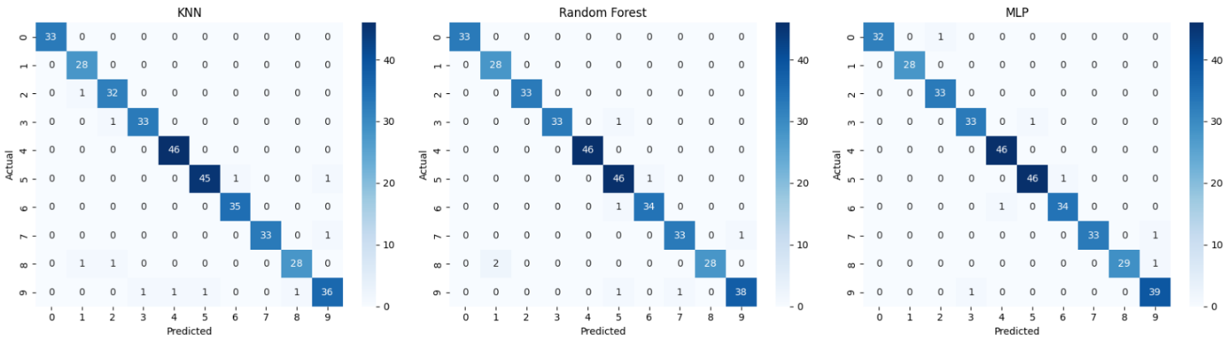

- Accuracy Score
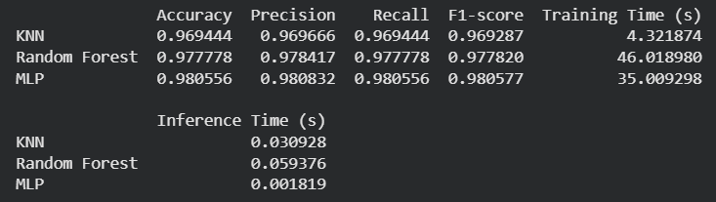
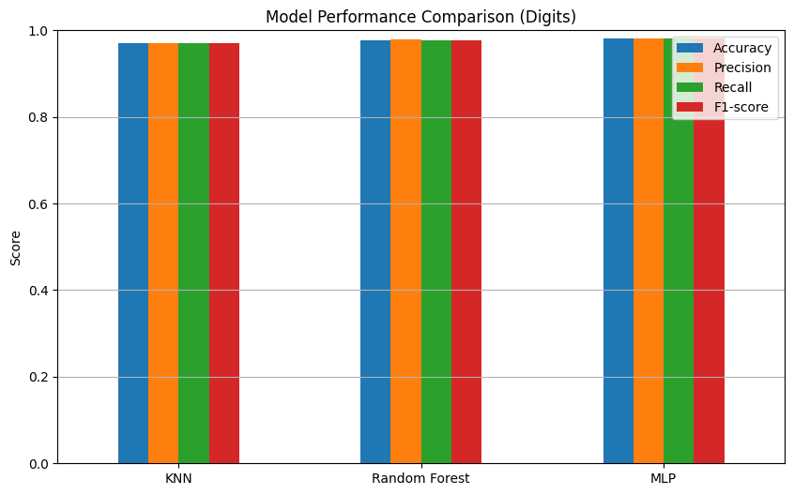

Observation and Result Analysis:
- Nature of the dataset
The dataset contains multiple input features and corresponding class labels.
The data is supervised, meaning each training sample has a known output class.
Features may be numerical (e.g., height, weight, marks) or categorical converted into numeric form.
The dataset may require normalization so that distance calculation is not biased toward large-value features.

- During Training Process
KNN does not build an explicit model; instead, it stores the training dataset.
During training, the algorithm:
- Stores feature values and labels
- Selects value of K
- Chooses appropriate distance metric (e.g., Euclidean distance)
No actual computation of parameters occurs, hence KNN is called a lazy learning algorithm.

- After the training Process
When a test data point is given:
- Distance between test point and all training points is calculated
- The K nearest neighbors are identified
- The output class is assigned using majority voting
The accuracy depends on the choice of K, dataset size, and feature scaling.

- Observation over the Learning Curve

The learning curve shows the relationship between model performance and value of K or training size.
- Small K → low bias, high variance (overfitting)
- Large K → high bias, low variance (underfitting)
- Optimal K gives balanced accuracy
Generally, accuracy improves with more training data but stabilizes after a certain point.

Post Lab Exercise:
  - Is KNN useful in regression-based problems?
Yes, KNN can be used for regression.
Instead of majority voting, the predicted value is calculated as the average (mean) of the values of the K nearest neighbors.

  - Why KNN is a non-parametric algorithm?
KNN is called non-parametric because it does not assume any fixed mathematical model or distribution of data.
It directly uses the training data to make predictions.

  - What are the assumptions of KNN approach?
- Similar data points exist close to each other
- Data points with similar features belong to the same class
- Distance metric correctly measures similarity
- Features should be properly scaled
- Training data is representative of the problem space

  - How can the KNN approach make the prediction of the unseen dataset?

For a new data point:
  - Calculate distance between the new point and all training data
  - Select K nearest neighbors
  - Use majority voting (classification) or average (regression)
  - Assign predicted output

  - Why is KNN called a Lazy Learner?

KNN is called a Lazy Learner because:
    - It does not build a model during training
    - It stores the dataset
    - Computation happens only when prediction is required

  - Why should we not use KNN for large dataset?
    - High memory requirement (stores entire dataset)
    - Slow prediction because distance must be calculated with all points
    - Computationally expensive for large data
    - Performance decreases when dataset becomes very large

